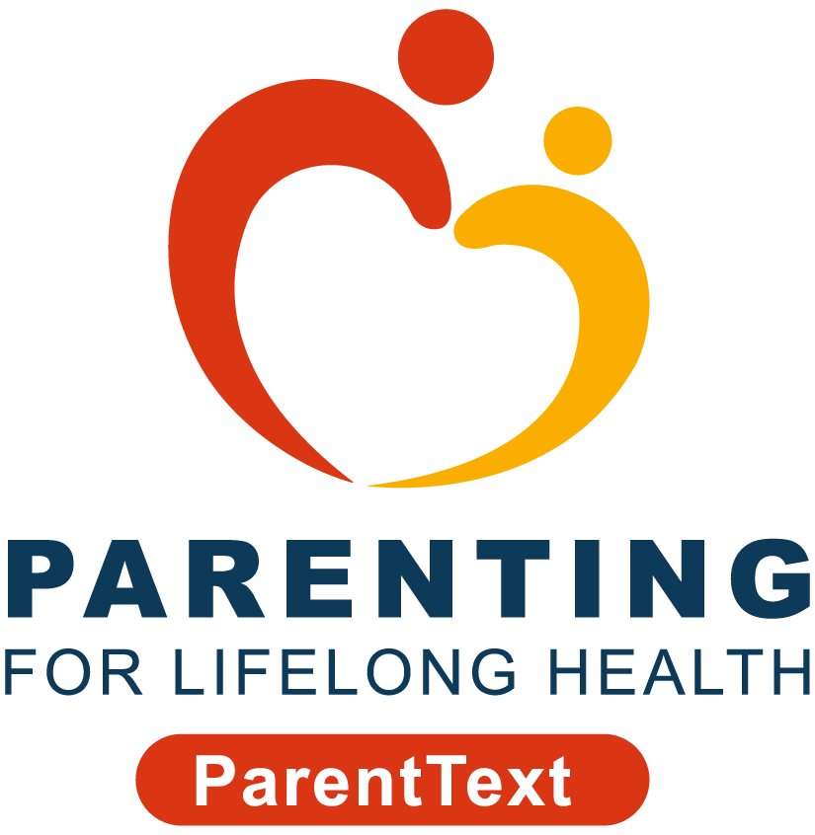



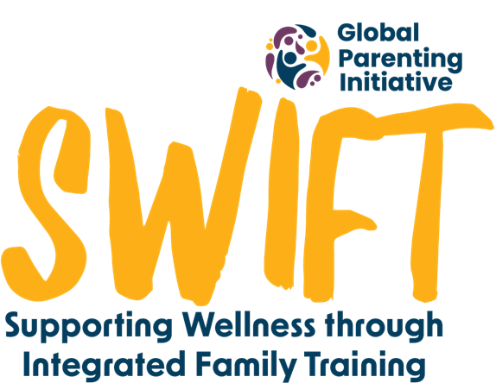
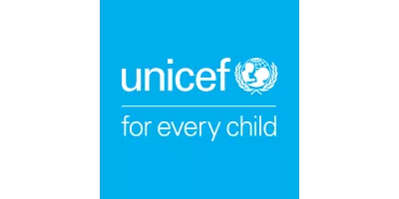
Appendix 13: SWIFT Child Safety Risk and Exposure Interviews with Adolescents: Parental Consent Form

As you are already part of our study, you will know that we are conducting a study on ParentText, the chatbot you have been working through. The study is carried out by researchers from the Universities of Cape Town in South Africa and the University of Oxford in the United Kingdom.
As part of understanding how ParentText has worked for you and your family, we would like to have a telephonic interview with the child that you care for and that you chose to work with while doing the programme. Before you decide whether to give us permission to speak to them, it’s important for you to know why we’re doing this research and what their participating in it would involve. All the information you might need is explained below but if you have any questions about your child’s participation or our study, please email the study team at swift@globalparenting.org or message us on WhatsApp at +27 XX XXX XXXX. We’re here to help you!
Why should I let my child participate?
Along with the information which you have shared, your child’s participation will contribute to the information we are gathering in order to understand how to support families like yours. We plan to share our results in reports and at conferences so others can learn from this study too. It is important for children to participate in things which are being done for them and that their voices are heard. Their participation helps us to understand what we might need to add to the program to improve it and what is working well.
What will my child’s participation look like?
If this is the first time, we are asking your permission to speak to your child, you would have opened this document while working through ParentText. If this is the case, then we are asking you to give permission for your child to participate in a telephone interview that will take about 15 minutes. We will ask your child questions about their experience of the child safety module which you did. All the questions will be multiple choice which means that they will only answer ‘Yes’/’No’, and ‘Never’/‘Sometimes’/’Often’.
Some adolescents will then be selected for a second interview. If this is the second time, we are contacting you about speaking to your child, and we have sent this document to you via WhatsApp, then your adolescent has been selected to take part in a longer interview. This will be a 30-minute phone call. These questions will also be about the child safety module, but it will allow them to answer in more detail and not be guided by the multiple-choice answers as in the previous interview. At this stage, we will call you again to get your permission for this second interview.
What will my child be asked?
Your child will be asked questions specifically related to the “keeping my child safe” module. These will be versions of the questions which we have asked you in your interviews so that we can understand their perspective of it.
Do I have to agree to be my child being interviewed?
No, it is up to you if you want to allow your child to join or not. Because they are a minor, it is your decision as to whether you will give your permission for them to be interviewed. Even if you have given your permission for them to be interviewed, we will still ask their permission before we actually start the interview. They are also able to skip any questions they do not want to answer or stop at any point during the interview.
What happens with my child’s information after being interviewed?
To protect their personal information (including their real name, contact details, and any other information that can identify them), we will give them a nickname.
We will, with your and your child’s permission, record the interview to help us remember their answers and later write down what was said. We may use an artificial intelligence (AI) software, Microsoft Transcriber, to transcribe the interviews at first, and then we will check/review these transcriptions. This AI-generated information will be processed and stored securely on password-protected University of Cape Town servers, and in accordance with POPIA. Only authorised members of the research team will be able to access it, and this data will be owned by the Global Parenting Initiative at the University of Cape Town.
We only collect what’s needed for the study and store it securely. Their information, the interview recording, your consent form and any other information either of you provide via email or WhatsApp, will be kept safe on secure servers at the University of Cape Town.
Interview recordings will be deleted after we have written our notes. Any details that identify you will be kept separate and only authorised staff can access them. All data will be kept for five years after the study, but personal information will be deleted when the study ends.
Ethics committees and monitors may check the information. The information will stay private unless the law says otherwise. After the study, we may share the information with other researchers but without your details.
What will I get told?
You will not have access to your child’s answers. However, if anything comes up in the interviews that is of concern to your child’s wellbeing, we have included in our discussion with them that we will share this with you after letting them know that we need to.
Does your child get anything for being interviewed?
As a thank you for taking part in the discussion, we'll give your child a R15 data voucher for the first 15-minute interview and a R35 data voucher for the longer interview (should they be chosen).

Who are some of the study team members?
The principal investigators of this study are Prof Cathy Ward and Cindee Bruyns and the Co-investigator is Carly Katzef, all from the University of Cape Town.
Are there any risks in being interviewed?
We don’t expect any risks of your child being interviewed. We will check in with them after the interview and ensure that we offer any additional support needed. If you or your child has any concerns after the interview, please reach out to our study team at swift@globalparenting.org or on WhatsApp at +27 XX XXX XXXX (messages only) or let your child call Childline on 116 (as can be found in your ParentText Help Menu).
Who pays for the study?
This study is part of the Global Parenting Initiative, funded by the LEGO Foundation, Oak Foundation, the World Childhood Foundation, The Human Safety Net, and the UK Research and Innovation Global Challenges Research Fund.
Data protection
The University Cape Town makes sure your and your child’s personal information is used safely and correctly, just for research. The study follows data protection laws like GDPR (General Data Protection Regulation) in the UK and POPIA (Protection of Personal Information Act) in South Africa. Any data that is transferred across borders will comply with POPIA.
Who has approved this study?
[Once the ethics has been approved this will read as follows: This study has received approval from the University of Cape Town’s Centre for Social Science Research Ethics Committee and University of Cape Town’s Faculty of Health Sciences Human Research Ethics Committee. The study has also been approved by the Western Cape Department of Health and Wellness and Department of Social Development, and City of Cape Town’s City health.]
Who do I contact if I have questions or concerns?
If you have any questions or concerns about your rights as a study participant, you can contact the study team at swift@globalparenting.org or on WhatsApp at +27 XX XXX XXXX (messages only).
If you have more questions or concerns about your rights, you can contact one of the ethics committees listed:
Name | Telephone | Email
University of Cape Town Centre for Social Science Research | +27 21 650 4656 | cssr@uct.ac.za
Human Research Ethics Committee |  | hrec-enquiries@uct.ac.za

Informed Consent to Take Part in the Study
Please read these statements carefully:
- I have read the information above and know what is expected of my child.
- I understand as my child’s guardian that I am giving consent for them to participate.
- I understand that even though I have given consent that my child will still be able to choose freely if they want to be interviewed.
- I understand that they can say no to being interviewed without any consequence.
- I had time to think about the information and have asked any questions I might have on either the email or message only WhatsApp number provided. I got satisfying answers if I did ask questions.
- I know who can see my child’s information, how it will be kept safe, and what happens to it after the study.
- I understand that I will not be notified of my child’s answers.
- I know that if the researchers pick up any safety concerns that they will let my child know that they will have to share the information before sharing it with me.
- I know I and my child won’t be named in any papers or reports from this study.
- I know who to contact if I have a problem with the study.
- You can contact me again if more information is needed from me.
- You can keep my contact information safe so you can tell me about the results of the study.
If you have read and understand the above document, agree with the messages and give consent to participate in the study, select “Yes” in WhatsApp. Select "No" in WhatsApp if you do not want to participate.

